Disability Artifact Archive

This archive, inspired by Zaynab Shahar and compiled by the participants of the Wabash Disability Pedagogy Grant (2021-2023), represents multi-media, first person, intersectional resources in disability theology. The archive can serve as inspiration for dynamic teaching and research as well as for those interested in learning more about disability. We believe these resources speak to disability theology futures.

Art Performance
- Alice Sheppard and Kinetic Light (An internationally recognized disability arts ensemble – Working in the disciplines of art, technology, design, and dance, Kinetic Light creates, performs, and teaches at the nexus of access, queerness, disability, dance, and race.)
- Claire Cunningham (A performer and creator of multi-disciplinary performance – Cunningham dances with crutches to study the use/misuse of her crutches and the exploration of the potential of her own specific physicality with a conscious rejection of traditional dance techniques.)
- Dan Daw (A disabled-led company blurring the divide between theater and dance)
- Jerron Herman (A dancer and writer who is inspired by personal histories and social legacies of disability aesthetics)
- Sins Invalid (A disability justice-based performance project)

Books
- Black Disability Politics by Sami Schalk (In addition to specific engagement with religion in Chapter 3, Schalk discusses the importance of not insisting on particular framings of disability—or an embrace of disability pride—as a prerequisite for belonging within disability movements/political efforts.)
- Kindling and Medicine Stories by Aurora Levins Morales (Morales is a phenomenal writer, whose meditations about disability, Judaism, colonialism, sexual violence, and Puerto Rican/Taino identity are gut-wrenching and thought-provoking.)
- The Future Is Disabled: Prophecies, Love Notes, and Mourning Songs by Leah Lakshmi Piepzna-Samarasinha (This book examines the futurity of disability justice in the wake of the pandemic.)
- This Here Flesh by Cole Arthur Riley (Riley writes about Black Christianity from the perspective of flesh, with ample meditations on what it’s like to navigate chronic illness as a Black woman in the white supremacist MIC.)
- Unmasking Autism by Devon Price (While not theological in nature, Price does set forth a paradigm for understanding autism rooted in anti-capitalism and abolition.)

Essays and Letters
- About Us: Essays from the Disability Series of the New York Times (First person essays from people with disabilities navigating the world)
- Places I’ve Taken My Body by Molly McCully Brown (A collection of essays where Brown explores the social geography of her childhood with cerebral palsy as the subject for her first poetry book)
- Rehearsals for Living by Robyn Maynard and Leanne Betasamasoke Simpson (A collection of letters between Maynard and Simpson discussing prefigurative politics in the wake of the pandemic in Toronto, where Maynard discusses the overlaps between her chronic illness and the politics of care in Canada)

Journal Articles
- Special Issue on “Neurodiversity and Theological Education” in The Journal of Disability & Religion, Fall 2023 (Majority neurodivergent Christian theologians offer perspectives on virtue, youth ministry, justice, liberation theology, congregations, and mental health and faculty life.)

Online Courses and Archives
- Cultivating God’s Brainforest by Institute for Youth Ministry, Princeton Theological Seminary (Online course for youth workers, featuring audio clips from neurodivergent youth, Christian sermons, testimonies, and art from neurodivergent scholars, theologians, and youth workers)
- Disability and Climate Change by Julia Watts Belser (A public archive project, learning with and from disabled, BIPOC climate activists)

Newsletters
- Crip News by Kevin Gotkin (Emphasizes disability arts, culture, and politics.)
- Disability Debrief by Peter Torres Fremlin (Emphasizes global disability social movements)

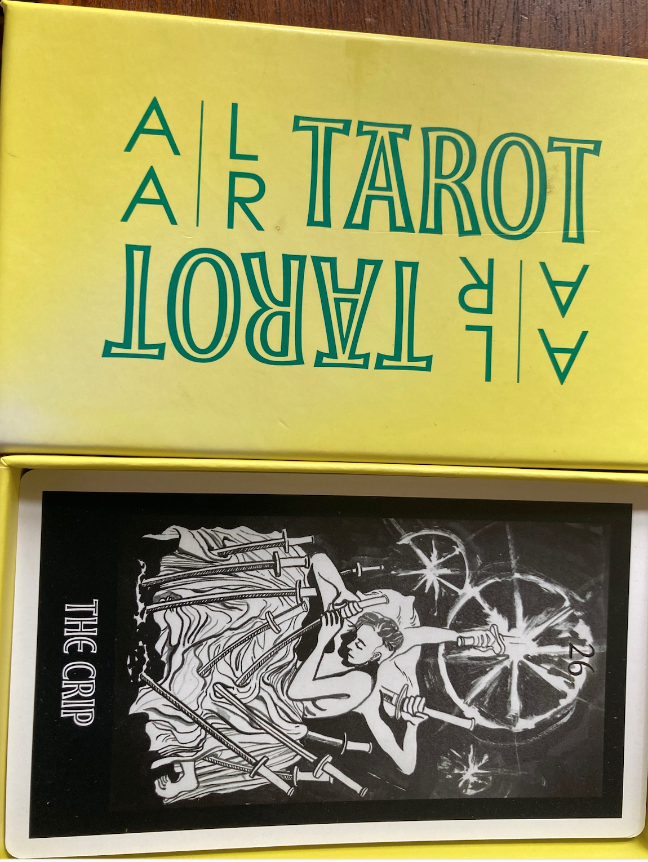
Objects
- “Open in Case of Emergency” (Asian American Tarot deck, leaning into multi-religious spaces – This brilliant resource is part of a multifaceted collection, curated by Mimi Khúc. Digital materials can be ordered here.)

Podcasts
- Disability Visibility Podcast by Alice Wong (Wong discusses disability rights, social justice, and intersectionality with disabled guests; while not theological in nature, it offers key insights into disability activism.)

Poetry
- The Divine: Dreams of Disabled Gods by Samir Knego (A collection of poetry and visual art—with image descriptions—that seeks to resist ableism and disability erasure in faith communities)
- Wound from the Mouth of a Wound by Torrin A. Greathouse (A gorgeous collection of poetry from trans femme cripple punk Greathouse, touching on issues of disability, religion, and gendered childhood socialization)

Have more to add? Email us at: disability_theology@baylor.edu

